Searching
Enter the name of a contact, company, matter etc in the search box at the top of the screen to quickly find the record:

The search box runs a key word search across OnePlace so will return multiple types of records. Click the relevant type from the list on the left to display only matters or contacts etc.

You can also use the filter icon to sort the data by a column header 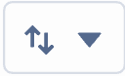

Alternatively, select a tab to view contacts, companies, lists etc. Each tab shows items you’ve recently viewed or edited.

At the top of each tab you will see:

List Views drop down which shows you available list views (searches)
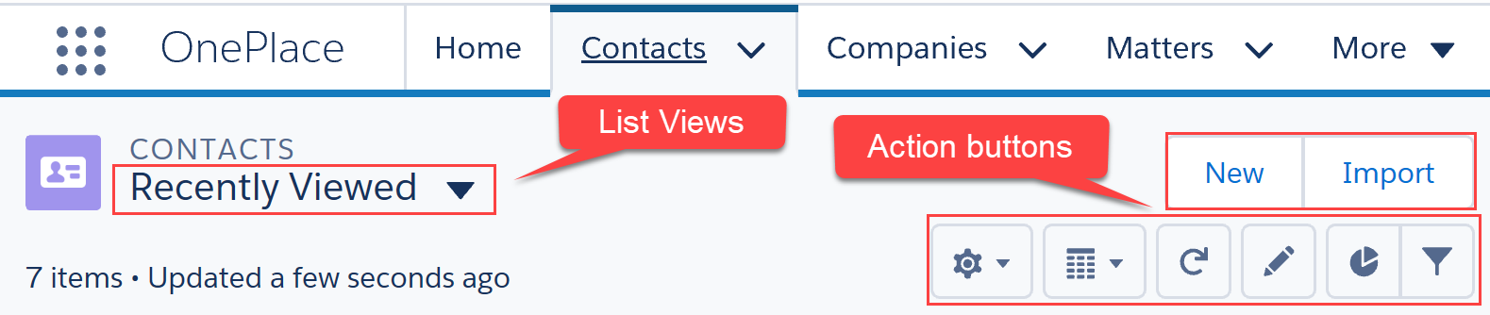

A set of action buttons:
- to create a new contact, company etc depending on the selected tab
- 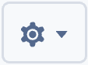 to create and edit new list views or select fields to display on a view
- 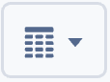 Display menu
- Refresh
- Edit (available on certain views)
- 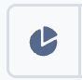 Charts (available on certain views)
- 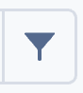 Filter (available on certain views)

Viewing Contacts
You can quickly find recently viewed contact, newly added contact and other lists set by your firm.

Click the Contacts tab

Make a selection from the list views drop down

Reorder the list by clicking on a column header, the first click sorts Ascending , the second click reorders Descending

Click a contact’s name to view full details
When viewing a contact, you will see the following information available:
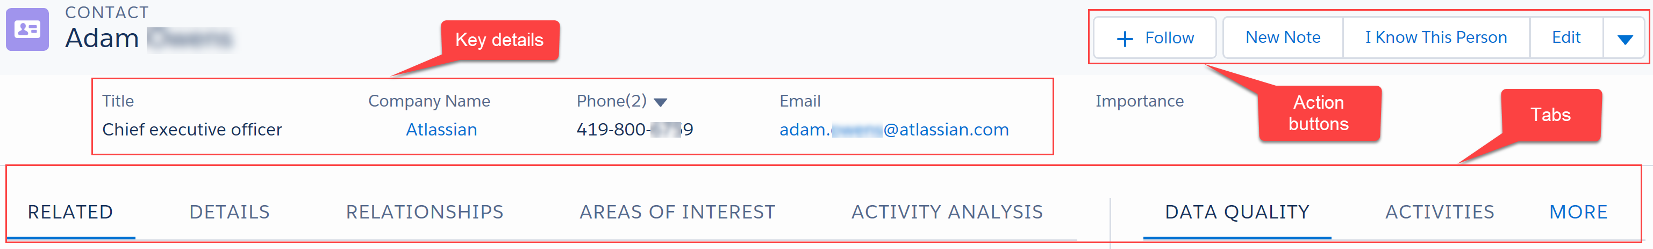

Key contact details are displayed at the top of the page.

Action buttons:
- Follow the contact on Chatter
- Edit
- Change Company (under drop down arrow) – update the company this contact works for
Tabs:
- Details – shows full contact details, contact preferences and marketing activity summary
- Related – shows you other companies the contact is linked to, other addresses recorded, lists, functions and publication information
- Relationships – allows you to view and create relationships with this contact
- Areas of Interest - can be populated by users or by the contact directly using emarketing integration
- Data Quality – shows potential duplicates and a Data Verification tool available subject to a licence
- Activities – record new activities. View and filter existing activities
- Chatter – comment on this contact – comments will be pushed to other users following this contact but visible to anyone viewing the record

Creating a new List View

Select the tab you want to create a list view within e.g. Contacts, Companies etc

Click the 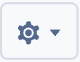 button and select New

Enter a name for the list view

Determine who can see the list view (only you or all users)

Click Save

In the Filters section on the right hand side click the Show me panel and select My Contacts or All Contacts

Click Add Filter and select the Field, Operator and Value

Click Done

Click Add Filter to enter further criteria

Click Save

Click Add Filter Logic to specify if each criterion should be separated with AND or OR
Note: AND v OR
For conditions where each criteria must be satisfied, choose AND
For conditions where any criteria can be satisfied choose OR

Click the button to Select fields to Display; then click Save

