Creating a new Contact

Select the Contacts tab and click New

Enter as many details as possible following any data entry standards your firm has in place

Company Name – enter the contact’s company name and select the relevant company from the options provided

If the company doesn’t already exist in OnePlace, click the New Company option to create the company first
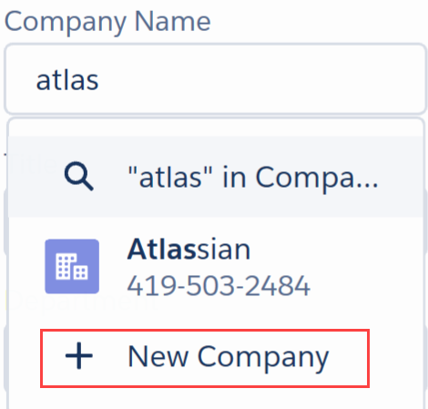

Address – use the Search Address option to easily find an address
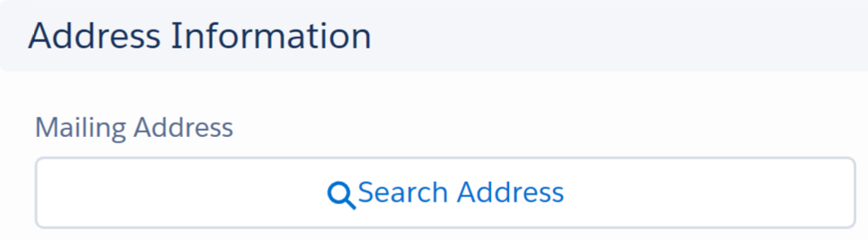

When all fields are complete click Save
Note that fields marked with a red asterisk are mandatory.

Note: You can also create a contact from a company record, this will ensure the contact is associated with the correct company:
Find the Company record, select the Related tab, expand the Contacts section and click New.

Editing Contacts
Search for the relevant contact and click the pencil icon in field you wish to update > edit as needed > click Save.

You can also click Edit at the top of the page to make changes to multiple fields:

Click Change Company to update the company a contact is linked to. Delete any old information e.g. job title, email or phone by clicking next to the field(s).

Viewing Contacts
You can quickly find recently viewed contact, newly added contact and other lists set by your firm.

Click the Contacts tab

Make a selection from the filter drop down

Reorder the list by clicking on a column header, the first click sorts Ascending , the second click reorders Descending

Viewing Contact Information

Click a contact’s name to view full details.
When viewing a contact, you will see the following information available:
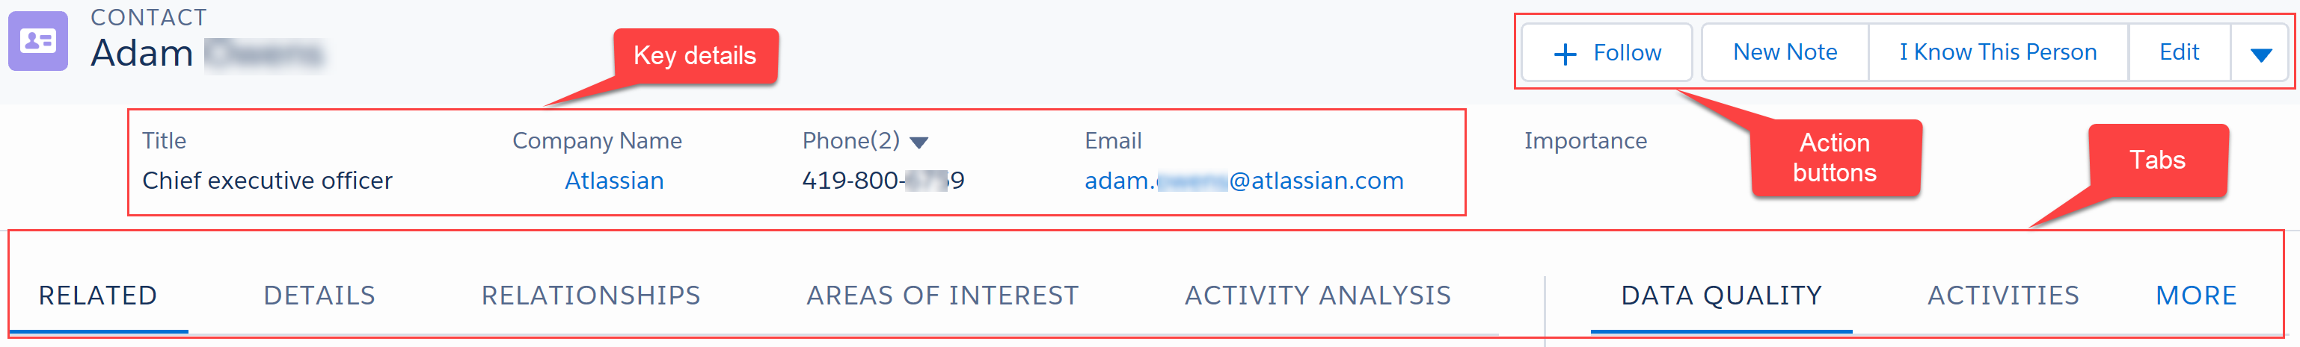

Key contact details are displayed at the top of the page.

Action buttons:
- Follow the contact on Chatter
- Edit
- Change Company (under drop down arrow) – update the company this contact works for
Tabs:
- Details – shows full contact details, contact preferences and marketing activity summary
- Related – shows you other companies the contact is linked to, other addresses recorded, lists, functions and publication information
- Relationships – allows you to view and create relationships with this contact
- Areas of Interest - can be populated by users or by the contact directly using emarketing integration
- Data Quality – shows potential duplicates and a Data Verification tool available subject to a licence
- Activities – record new activities. View and filter existing activities
- Chatter – comment on this contact – comments will be pushed to other users following this contact but visible to anyone viewing the record

Working on behalf of your fee earner
Click Work on Behalf in the bottom left corner of your screen to search for the fee earner you want to work as:

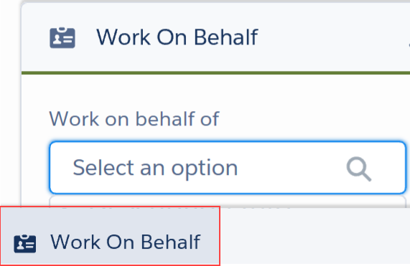

This will allow you to add Contacts, Activities, Relationships etc as your fee earner.
To go back to working as yourself click Reset:

Note: changes made to contact details will display your user name in the Contact History section regardless of who you are working as.

Viewing Marketing Information
When viewing a contact, select the Related tab:

The Events and Training section will show all events the contact has been invited to, their response and attendance.

The Publication Subscribed section will show you any newsletters sent to the contact and how many times they’ve clicked a link within the newsletter (if you have integration with your emarketing system).

Adding a Contact to a List
Lists are used for events and newsletters – you can add contacts to a list for them to receive an invitation or publication. The marketing team will send you a link to allow you to add your contacts to a list. The link will show you:

Guidelines on the type of contacts that should be added > click Contribute Contacts to List

Add Contacts screen will allow you to view contacts:
- I work with – contacts you are linked to via a matter
- I know – contacts where you have a knows relationship recorded
- I added to list
- Others added to list

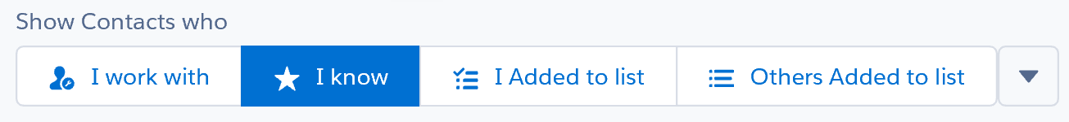

Select the contact you want to add to the list

Click Save and continue later OR List Completed

Adding Activities
Activities are used to record what we are doing with contacts and companies e.g. business development meetings and phone calls. They can be added directly from your Outlook calendar and inbox via Lightning for Outlook.

You can also create new activities in OnePlace:

Click the Activities tab on a contact or company and select New Task – to record a meeting or to assign a task to yourself or another person

Complete the following details:
- Subject – heading for the task/meeting
- Related To – click on the drop down to relate the task to a company, matter, publication, event etc
- Name – click on the drop down to search for the contact related to this task
- Comments – for extra information
- Type – select the relevant type from the drop down list: Call, Meeting etc
- For tasks: Assigned to - will pick up your details (or the person you’re working on behalf of), you can amend this to set a task for another user
- For tasks: Due date – enter the date the task is due to take place
- For tasks: Status – can be updated as the task progresses: Not Started, In Progress, Completed, Waiting on someone else, Deferred

Click Save
The Status of the task will determine if it is visible in the Next Steps or Past Activities section.
Next Steps: Not Started, In Progress, Waiting on someone else, Deferred
Past: Completed

Adding a Relationship
When you add a contact to OnePlace, a known by relationship is created between you and the contact.
You can also add this relationship to contacts which are already in the system by clicking I know This Person at the top of the contact page:

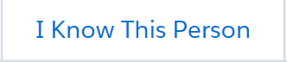

You can easily find these contacts by selecting the My Contacts list view on the Contacts tab.

You can also build other relationships between contacts and/or companies:

Search for the relevant contact and click the Related tab

In the Relationships section click New

Select the relevant relationship type (Board Member, Consultant, Member of etc)

Click Next

Search for the related contact/company/user – depending on the relationship type selected

Click Save

