Outlook panel
The panel in Outlook will display details about contacts who are included on emails and calendar items. You can also search for, and add, new contacts, companies, tasks etc.

On the home ribbon within Outlook, click the View button to display the Salesforce panel:

You can pin the panel if using Outlook 2016:
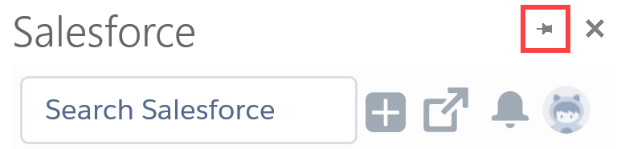

The top of the panel allows you to search for any item within OnePlace.
allows you to add new items e.g. contacts and tasks.
opens the OnePlace web client.

Viewing contact information
When an email is selected, or a calendar item is open the side panel will display the details for contacts and companies which exist in OnePlace.

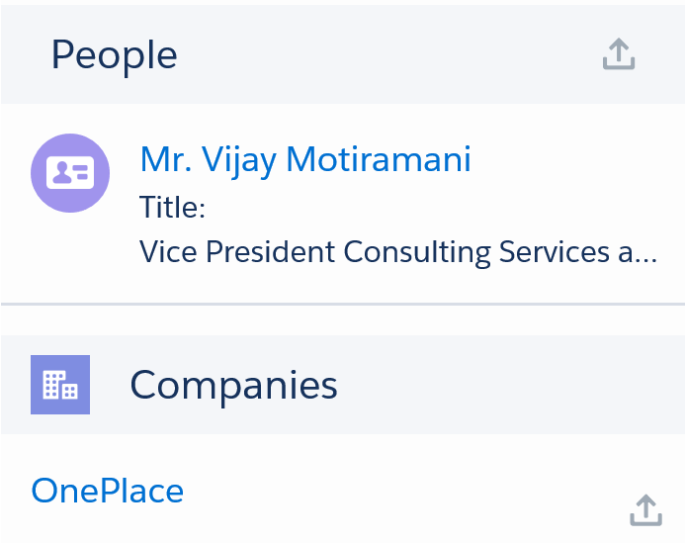

Clicking a contact’s name will show their company, job title, phone and email (if available in OnePlace) and full details about the contact in the tabs:

The current tab is indicated by bold blue line.

- Details – shows full contact details, contact preferences and marketing activity summary
- Chatter – share an update about this contact. View, filter and search recent chatter activities and comment or like updates.
Comments will be pushed to users who are ‘following’ this contact but will be visible to anyone viewing the record.

- Activity – View and filter existing activities. [is a ‘new task’ option usually available for clients or do they use the + > New Task at the top of the screen?]
- Related – shows you other companies the contact is linked to, other addresses recorded, lists, function and publication information

Adding a new contact
For any contacts which do not exist you will see the option to .

NOTE: Contacts are matched by their email address so a contact may exist within OnePlace but with an out of date or alternative email address.

There are 2 ways to add new contacts from the panel:

Clicking the link will display all contact fields as you would see in web client

Using the and selecting New Contact at the top of the panel will show a smaller set of fields to complete

(Company must already exist in OnePlace, if not, go to the web Client to create the company first) OR click and select New Company

Adding/deleting a meeting to OnePlace

BD meetings

When a calendar item (meeting request or appointment) is open

Open the relevant calendar item

Click the View button on the toolbar

For contacts found in OnePlace click the icon to the right of each contact to display the calendar item as an activity against their record

You can also search for contacts and link the calendar item to their records

If the item

- Existing item
New meeting request
Create and send the meeting request as usual
Reopen the meeting and then use the icon next to each contact to include them on the activity

New appointment
Create and save as usual. As this isn’t being sent to anyone no contacts will automactially be populated in the panel. To create this activity in OnePlace, search for a contact / company and click the icon next to each contact you want to include on the Activity.

Adding an email to OnePlace
You can link an email to a contact in OnePlace in the same way you can link a meeting from the calendar.

Select the relevant email
Click the icon next to each contact

Searching

Enter the name of a contact, company, matter etc in the search box at the top of the panel to quickly find a record:

The search box runs a key word search across OnePlace so will return multiple types of records.
Scroll through the Top Results to see the most accurate matches or click the relevant tab at the top of the panel to display only companies or lists etc.
A full list of options can be seen under the More tab.

