Field Security: visible to all
This document lists OnePlace fields that should be visible to all users and the integration/component/other OnePlace-related reasons why

Table of Contents
1. Introduction 2
2. List of Fields 2

Introduction

A number of fields in OnePlace need to have their security set as ‘Visible’ to all users due to their use by third-party integrations, Lightning components created by the OnePlace technical team or other OnePlace-related functionality.
Note: the list below does not contain fields such as First Name, Last Name, Company, Email, etc for the New Contact Wizard or Client Number for financial integration but focuses on less obvious fields that are more likely to be hidden (or to be edited to be hidden) to non-System Admin users. e.g. if they aren’t often used in page layouts or reporting by clients.

List of Fields

Object | Field Name | Integration/Component | Impact if not visible
Contact | OnePlace__Implied_Consent_Date__c | New Contact Wizard component* | ‘No such column’ error appears on page three (last page) of the wizard
Contact | OnePlace__Consent_Comment__c | New Contact Wizard component* | ‘No such column’ error appears on page three (last page) of the wizard
Contact | OnePlace__Consent_Methods__c | New Contact Wizard component* | ‘No such column’ error appears on page three (last page) of the wizard
Contact | OnePlace_Express_Consent_Date_c | New Contact Wizard component* | ‘No such column’ error appears on page three (last page) of the wizard
Contact | OnePlace_Express_Contact_Consent_c | New Contact Wizard component* | ‘No such column’ error appears on page three (last page) of the wizard
Contact | OnePlace_Undetermined_Consent_c | New Contact Wizard component* | ‘No such column’ error appears on page three (last page) of the wizard
Contact | OnePlace__Photo__c | New Contact Wizard component* | Various errors
Contact | OnePlace__Token__c | New Contact Wizard component* | ‘No such column’ error appears on page three (last page) of the wizard
Company Address | OnePlace__Language__c | New Contact Wizard component* | ‘No such column’ error appears on page two (address page) of the wizard
Publications | OnePlace__Active__c | Vuture integration | List won’t export to Vuture
Functions | OnePlace__Active__c | Vuture integration | List won’t export to Vuture
Functions | OnePlace__Total_Count__c | Function Summary Lightning component** | ‘No such column’ error appears in component
Functions | OnePlace__Total_Opened__c | Function Summary Lightning component** | ‘No such column’ error appears in component
Functions | OnePlace__Total_Count_Excluded__c | Function Summary Lightning component** | ‘No such column’ error appears in component
Functions | OnePlace__Cost_Per_Contact__c | Function Summary Lightning component** | ‘No such column’ error appears in component
Functions | OnePlace__Total_Cost__c | Function Summary Lightning component** | ‘No such column’ error appears in component
Functions | OnePlace__Count_Accepted__c | Function Summary Lightning component** | ‘No such column’ error appears in component
Functions | OnePlace__Forecast_Cost__c | Function Summary Lightning component** | ‘No such column’ error appears in component

*New Contact Wizard setting in Contact object:
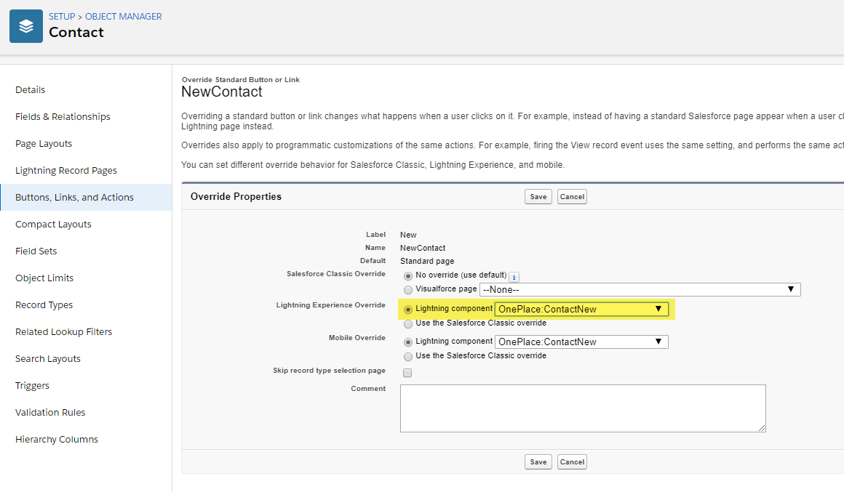

**Function Summary Lightning component
Note that if these fields are removed from the component in the Lightning page editor, they do not need to be visible to users

